Booking Hotel

Use-Case Specification

Version 1.1

Revision History

|  |  |  |  |
| --- | --- | --- | --- |
| **Date** | **Version** | **Description** | **Author** |
| 09/11/2022 | <1.0> | Use-case: Create a new account, Use-case: Booking | Le Cong Huu, Le Tan Kiet, Ngo Thanh Luc, Nguyen Long Vu, Nguyen Thi Anh Tuyet |
| 16/11/2022 | <1.1> | Use-case: Customer Support, Use-case: Promotion | Ngo Thanh Luc |
| 16/11/2022 | <1.1> | Use-case: Create room, Use-case: Edit room | Le Cong Huu |
| 16/11/2022 | <1.1> | Use-case: Search, Use-case: View detail | Le Tan Kiet |
| 16/11/2022 | <1.1> | Use-case: Payment, Use-case: Add review | Nguyen Thi Anh Tuyet |
| 16/11/2022 | <1.1> | Use-case: Dashboard, Use-case: Login, Use-case: Edit Profile | Nguyen Long Vu |

**Table of Contents**

Use-case Model 4

Use-case Specifications 5

Use-case: Create a new account 5

Use-case: Booking 5

Use-case: Customer Support 6

Use-case: Promotion 7

Use-case: Create a new room 8

Use-case: Edit a room 8

Use-case: Search 9

Use-case: View Detail 9

Use-case: Payment 9

Use-case: Add a review 10

Use-case: Dashboard 10

Use-case: Login 10

Use-case: Edit Profile 11

# Use-case Model

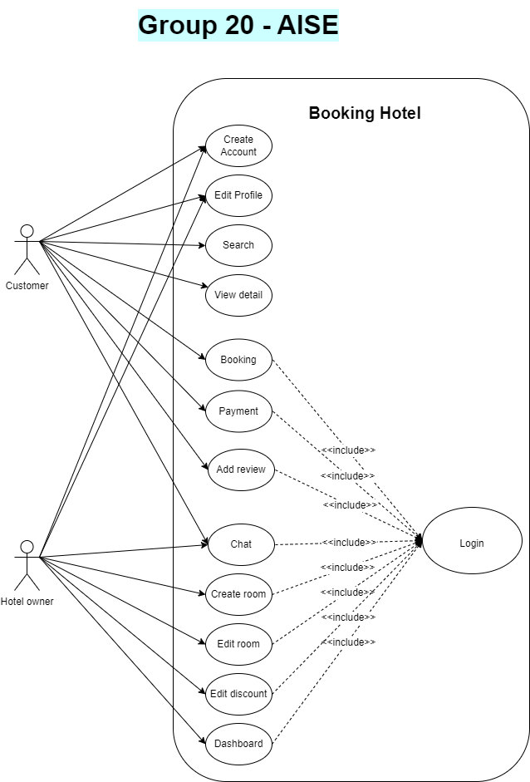

# Use-case Specifications

## Use-case: Create a new account

|  |  |
| --- | --- |
| Use case Name | Create a new account. |
| Brief description | This use case describes how the user can create a new account. |
| Actors | Hotel owner and Customer |
| Basic Flow | 1. At the signup page, the user enters username, password, phone number, mail, account type (customer or hotel owner), id card, agree with our term services. 2. Users click on ‘Signup’. 3. System will announce “Signup successfully!” , create a new account and add the account to the database. 4. Back to the login page, the user enters username and password to login. |
| Alternative Flows | **Alternative flow 1: User cannot register because of invalid username**   1. From #2 of the basic flow, if username is invalid, system will announce “Using other username!”. 2. Redo #1 of the basic flow.   **Alternative flow 2: User cannot register because of invalid mail**   1. From #2 of the basic flow, if mail is invalid, system will announce “This mail has existed!”. 2. Redo #1 of the basic flow. |
| Pre-conditions | User goes to signup page. |
| Post-conditions | The user creates a new account successfully. |

## Use-case: Booking

|  |  |
| --- | --- |
| Use case Name | Booking |
| Brief description | This use case describes how Customer can book hotel. |
| Actors | Customer |
| Basic Flow | 1. The system displays hotel suggested at home page, or user can search the hotel on search input. 2. System displays the hotels found. 3. Customers click hotel card to view detail. 4. Customer picks check-in, check-out date to view price. 5. Customer click “Booking” button if available. 6. System redirects to payment page. |
| Alternative Flows | **Alternative flow 1: User cannot find hotels searched**   1. From #1 of the basic flow, user enters another term 2. Continue step #2 in the basic flow |
| Pre-conditions | User already login. |
| Post-conditions | The user successfully books the hotel. |

## Use-case: Customer Support

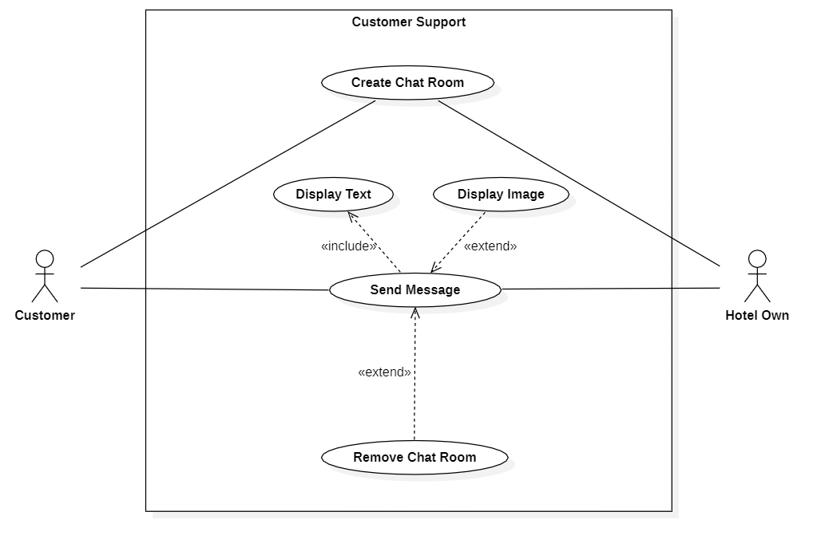

|  |  |
| --- | --- |
| Use case Name | Customer Support |
| Brief description | This use case describes how the Customer and Hotel Owner chat together |
| Actors | Customer, Hotel Owner |
| Basic Flow | 1. The system displays customer support on details of hotel. 2. The Customer clicks on customer support to chat with the hotel owner. 3. The Customer and hotel owner do chat together for services. 4. The customer already login and paid for the room of hotel |
| Alternative Flows | **Alternative flow 1: The Hotel Owner is offline**   1. Automating Text Messages will show the hotline whenever start chatroom 2. Customer can call the hotline for quick service. |
| Pre-conditions | User already login and paid for the room of hotel |
| Post-conditions | The user successfully chats with the hotel owner. |

## Use-case: Promotion

|  |  |
| --- | --- |
| Use case Name | Coupon Codes |
| Brief description | This use case describes Customer apply coupon and The Hotel Own |
| Actors | Customer, Hotel Owner |
| Basic Flow | **Customer:**   1. From details of picked room, customers enter the coupon or pick the coupon available for this room 2. Customers click the “Booking” button if available. 3. The system redirects to the payment page with discounted price. 4. Customers checkout price and click the “Pay now!” to finish booking a room.   **Hotel Owner:**   1. From edit room screen, click “Coupons” for add/edit coupon 2. Set the percent discount and maximum discount price of coupon 3. Save the change |
|  | **Alternative flow 1: Coupon Invalid Coupon/Expired**   1. From #1 of the basic flow, user enters another coupon or do not use the coupon 2. Continue step #2 in the basic flow |
| Pre-conditions | User and Hotel Owner already login. |
| Post-conditions | The user successfully applies the coupon.  The hotel owner created/updated coupon. |

## Use-case: Create a new room

|  |  |
| --- | --- |
| Use case Name | Create a new room. |
| Brief description | This use case describes how the user can create a new room. |
| Actors | Hotel owner |
| Basic Flow | 1. At the admin home, the user clicks on “create a new room” button. 2. The system opens “create a room” page. 3. The user enters name, star rating, number people, address, outstanding features, other features, price of room/hotel. 4. The system creates a new room if the room valid information. |
| Alternative Flows | **Alternative flow 1: The room invalid information**   1. From #3 of basic flow, user enters invalid information. 2. Error message and continue step #3 in the basic flow. |
| Pre-conditions | Hotel Owner already login. |
| Post-conditions | The user creates a new room/hotel successfully. |

## Use-case: Edit a room

|  |  |
| --- | --- |
| Use case Name | Edit a room already exist. |
| Brief description | This use case describes how the user can edit a room which they manage. |
| Actors | Hotel owner |
| Basic Flow | 1. At the admin home, the user clicks on “edit room” button at that room. 2. The system opens “edit room” page of that room. 3. The user edits information room. 4. The system repairs room information if correction valid information. |
| Alternative Flows | **Alternative flow 1: The correction invalid information**   1. From #3 of basic flow, user edits invalid information. 2. Error message and continue step #3 in the basic flow. |
| Pre-conditions | 1. Hotel Owner already login. 2. Hotel Owner had a room exist. |
| Post-conditions | The user successfully edits a room. |

## Use-case: Search

|  |  |
| --- | --- |
| Use case Name | Search a room. |
| Brief description | This use case describes how the user can search a room. |
| Actors | User |
| Basic Flow | 1. At the home page, the user enters name of hotel to search input to search hotels. 2. The system display hotels found. |
| Alternative Flows | **Alternative flow 1: The room invalid search input**   1. From #1 of basic flow, user enters invalid name or address. 2. Display search not found page and continue step #1 in the basic flow. |
| Pre-conditions | The user visits website. |
| Post-conditions | The user searched an appropriate room. |

## Use-case: View Detail

|  |  |
| --- | --- |
| Use case Name | View detail of room |
| Brief description | This use case describes how the user can view detail of the room. |
| Actors | User |
| Basic Flow | 1. At the home page or after searched, the user clicks on “view detail” button in hotel card to view detail. 2. The system opens detail page of that room. 3. The user sees information of that room. |
| Alternative Flows | **Alternative flow 1: Details of the room load fail**   1. From #2 of basic flow, internet occur error. 2. The user reload website and continue step #2 in the basic flow |
| Pre-conditions | The user visits website. |
| Post-conditions | The user viewed detail of a room and decided booking or no. |

## Use-case: Payment

|  |  |
| --- | --- |
| Use case Name | Payment |
| Brief description | This use case describes how customer pay for a product |
| Actors | Customer |
| Basic Flow | 1. At payment page, customer selects one of the payment methods (Banking or Momo). 2. Customer enters payment details for selected method. 3. Customer scans the QR code for payment. 4. Customer selects “Pay”. 5. System displays “Booking succeed” if payment succeed. |
| Alternative Flows | **Alternative flow 1: Payment failed**   1. After #4 of the basic flow, system detects that payment failed and displays “Booking cancelled due to payment failure”. 2. Customer selects “Return to payment methods”. 3. Continue step #3. |
| Pre-conditions | Customer logged in, selected booking rooms and selected “Booking” |
| Post-conditions | Room successfully booked and status set to “Booked”, customer receives booking information in their account. |

## Use-case: Add a review

|  |  |
| --- | --- |
| Use case Name | Add a review |
| Brief description | This use case describes how customer add a review for a booking |
| Actors | Customer |
| Basic Flow | 1. Customer selects a past booking and selects “Add review”. 2. Customer selects rating (1 - 5 stars). 3. Customer enters detailed review of at most 500 words and images. 4. Customer selects “Send review”. 5. System displays “Review added”. |
| Alternative Flows | **Alternative flow 1: Customer entered too long review**   1. From #3 of the basic flow, customer entered a review longer than 500 words. 2. System shows “Review is too long”, user can not add more words, but user can edit. 3. Continue step #4. |
| Pre-conditions | Customer logged in and completed at least one booking. |
| Post-conditions | Review added. |

## Use-case: Dashboard

|  |  |
| --- | --- |
| Use case Name | Dashboard |
| Brief description | This use case describes how the hotel owner can view room data (revenue, total customer,…) |
| Actors | Hotel owner |
| Basic Flow | * + - 1. At the home page, user click on the profile.       2. User click on dashboard.       3. The system display dashboard. |
| Alternative Flows |  |
| Pre-conditions | The users login as hotel owner. |
| Post-conditions | Dashboard display on screen. |

## Use-case: Login

|  |  |
| --- | --- |
| Use case Name | Login |
| Brief description | This use case describes how the user can login. |
| Actors | User |
| Basic Flow | 1. User access website. 2. User enter username (email, phone number) and password. 3. Click on the login button. 4. System authenticate user data and allow user access website. |
| Alternative Flows | **Alternative flow 1: User login with gmail provider**   * 1. User select login with gmail option.  1. Display login popup of google. 2. Google authenticate user data and allow user access website. |
| Pre-conditions | The user visit login-page of website. |
| Post-conditions | Access website as customer or hotel owner. |

## Use-case: Edit Profile

|  |  |
| --- | --- |
| Use case Name | Edit Profile |
| Brief description | This use case describes how the user can edit profile. |
| Actors | User |
| Basic Flow | 1. At home page, user click on profile. 2. Click on edit profile. 3. Edit profile data. 4. Click on save. 5. System update profile data. |
| Alternative Flows |  |
| Pre-conditions | User already login. |
| Post-conditions | Profile data updated |